QUESTIONS FOR ADDITIONAL STUDY

1. Tell your story. Describe a time in your life when you were grateful

for something God had done in your life.

2. What are some of the things that believers can take for granted?

3. Read the following passages and note the Bible says about

gratitude:

a) Psalm 136:1

b) Romans 1:21

c) Ephesians 5:20

d) Colossians 3:17

e) I Thessalonians 5:18

f) Hebrews 12:28

g) James 1:17

4. What did Jesus mean when he told the Samaritan, “Your faith has

made you well.”

5. What practical application are you going to make from this week’s

message? (*Share your decision with another person*.)

* I am going to thank God each day for three things.
* I am going to set aside some time each day to listen to worship music.
* I am going to memorize James 1:17.

Cornerstone Church August 11, 2024

Luke 17:11-19 Study Series #073

***Gratitude Toward God***

**I. Introduction**

A. Gratitude in Prayer

B. Leprosy in the Bible

(See Leviticus 13:1-46; Deuteronomy 24:8; Numbers 5:2;

II Chronicles 26:21)

**II. Gratitude Toward God**

A. The Request

(See Luke 17:11-13; Leviticus 13:45; II Kings 7:3;

Hebrews 9:22; Matthew 9:27; Matthew 15:22;

Mark 10:47-48)

B. The Reply

(See Luke 17:14; Luke 5:12-14; Matthew 8:2-4; Mark 1:40-45;

Matthew 9:6-7; Mark 1:31; Matthew 9:20-22; Mark 8:22-25;

John 9:6; Hebrews 11:1)

C. The Result

(See Luke 17:14; II Kings 5:1-14)

D. The Reaction

(See Luke 17:15-16; Exodus 20:3-5; Exodus 34:14;

Deuteronomy 5:7-9; John 4:6)

E. The Response

(See Luke 17:17-18)

F. The Revelation

(See Luke 17:19; Matthew 1:21; Luke 7:50; John 3:17;

Acts 2:47)

**IV. Conclusion**

(See Matthew 5:45)

If you would like to know more about what it means to be a Christian, or if you would like to talk with someone or have someone pray for you, please see the pastor after the service and he or one of our church leaders will be glad to speak with you.

**Passage of Study**

**Luke 17:11-****19**

**11**While He was on the way to Jerusalem, He was passing between Samaria and Galilee. **12**As He entered a certain village, ten leprous men who stood at a distance met Him; **13**and they raised their voices, saying, “Jesus, Master, have mercy on us!” **14**When He saw them, He said to them, “Go and show yourselves to the priests.” And as they were going, they were cleansed. **15**Now one of them, when he saw that he had been healed, turned back, glorifying God with a loud voice, **16**and he fell on his face at His feet, giving thanks to Him. And he was a Samaritan. **17**Then Jesus answered and said, “Were there not ten cleansed? But the nine—where are they? **18**Was no one found who returned to give glory to God, except this foreigner?” **19**And He said to him, “Stand up and go; your faith has made you well.”

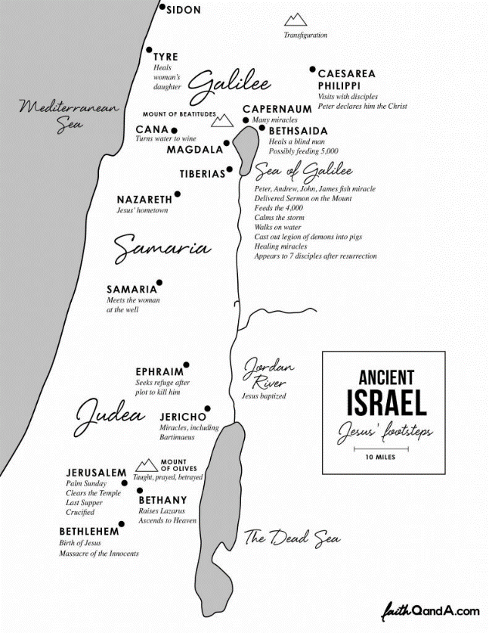

All quotations taken from the New American Standard unless otherwise noted. NASB. Nashville, TN: Thomas Nelson Publishers 1995. A free PDF of this note sheet is available: www.cssbchurch.org/sermons-2. © 2024.