QUESTIONS FOR ADDITIONAL STUDY

1. Tell your story. Describe a time in your life when you had to take a

stand for your faith even though you knew it could cause conflict

with others. How did you handle it?

2. The Bible says, “Be angry and yet do not sin,” but the Bible also

says, “The anger of man does not achieve the righteousness of

God.” When is it right for a Christian to be angry and when is it

wrong for a Christian to be angry?

3. Read the following passages and note the Bible says about anger:

a) Psalm 37:8

b) Proverbs 14:29

c) Proverbs 15:1

d) Proverbs 19:11

e) Matthew 5:22

f) Ephesians 4:26-27

g) James 1:19-20

4. What prophet did Jesus quote to defend His actions in the temple?

5. What practical application are you going to make from this week’s

message? (*Share your decision with another person*.)

* I am going to take a stand for my faith this week even though it may not be popular with others.
* Next time I get angry, I am going to evaluate the reason for my anger to see if I am allowing ungodly anger in my life.
* I am going to memorize James 1:19-20.

Cornerstone Church October 13, 2024

Luke 19:45-48 Study Series #082

***Time to Clean House!***

**I. Introduction**

A. A Bad Day?

(See Matthew 21:17; Mark 11:12-14; Luke 19:45;

Matthew 21:12; Mark 11:15-16; John 2:13-22)

B. The Triumphal Entry

(See Luke 19:28-44; Mark 11:11)

C. The Lodging in Bethany

(See John 11:1; Matthew 21:7)

**II. Time to Clean House!**

A. His Divine Mission

(See Luke 19:45; Matthew 21:12; Mark 11:15; John 6:14-15)

B. His Divine Action

(See Luke 19:45; Matthew 21:12; Mark 11:15-16;

John 2:13-17; Numbers 19:2; Numbers 28:11;

Leviticus 1:2-3)

C. His Divine Authority

(See Luke 19:46; Matthew 21:13; Mark 11:17; John 2:19-21;

Hebrews 3:6; Isaiah 56:6-7; Psalm 27:4; I Kings 8:29-39;

I Kings 8:42; I Kings 8:61-62; Acts 8:26-39; Jeremiah 7:11;

Deuteronomy 12:5-7)

D. His Divine Message

(See Luke 19:47; Luke 20:1; Luke 21:37-38; Matthew 21:14)

E. His Divine Protection

(See Luke 19:47-48; Mark 11:18; Luke 6:7; Luke 11:53;

Luke 15:2; Luke 23:21; Matthew 21:15; Mark 11:18;

Isaiah 53:3; Acts 2:23)

**III. Conclusion**

If you would like to know more about what it means to be a Christian, or if you would like to talk with someone or have someone pray for you, please see the pastor after the service and he or one of our church leaders will be glad to speak with you.

**Passage of Study**

**Luke 19:45-48**

**45**Jesus entered the temple and began to drive out those who were selling, **46**saying to them, “It is written, ‘And My house shall be a house of prayer,’ but you have made it a robbers’ den.”

**47**And He was teaching daily in the temple; but the chief priests and the scribes and the leading men among the people were trying to destroy Him, **48**and they could not find anything that they might do, for all the people were hanging on to every word He said.

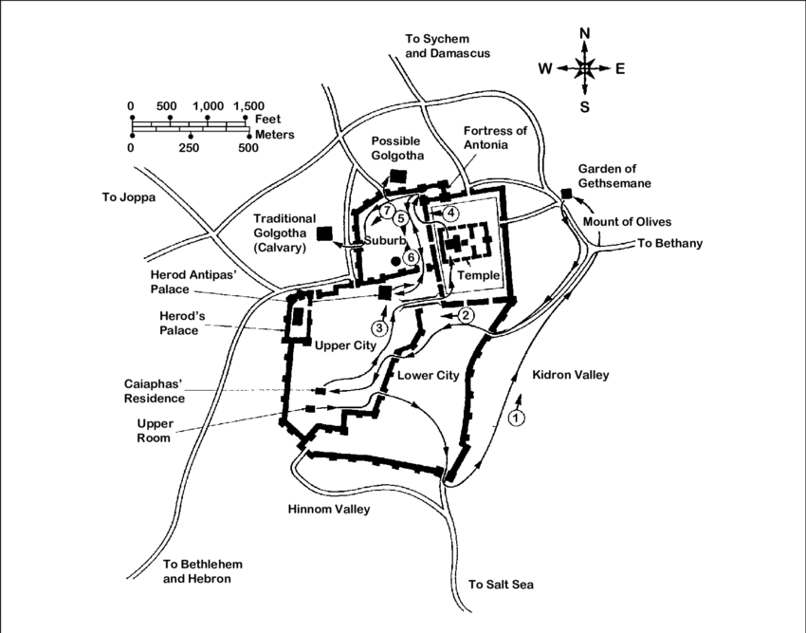

All quotations taken from the New American Standard unless otherwise noted. NASB. Nashville, TN: Thomas Nelson Publishers 1995. A free PDF of this note sheet is available: www.cssbchurch.org/sermons-2. © 2023.