QUESTIONS FOR ADDITIONAL STUDY

1. Tell your story. Describe a time in your life when you made a

personal sacrifice so you could give something to another person.

2. What are some of the reasons why people are hesitant to give to

others? Are there good reasons *not* to give to another person?

3. Read the following passages and note the Bible says about our

giving:

a) Proverbs 3:27

b) Proverbs 11:24-25

c) Proverbs 19:17

d) Malachi 3:10

e) Acts 20:35

f) II Corinthians 8:24

g) II Corinthians 9:6-7

4. What are some of the *wrong* reasons for giving?

5. What practical application are you going to make from this week’s

message? (*Share your decision with another person*.)

* I am going to anonymously give to someone I know who has a legitimate need.
* I am going to set aside some money or time to help someone in need this Christmas season.
* I am going to memorize Acts 20:35.

Cornerstone Church December 1, 2024

Luke 21:1-4 Study Series #088

***The Widow’s Gift***

**I. Introduction**

A. The Gift

B. The Disclaimer

(See II Corinthians 9:7; Philemon 1:14; Matthew 6:1-4)

C. The Temple Offering

(See Acts 3:2; Acts 3:10)

**II. The Widow’s Gift**

A. God Sees Our Faithfulness in Our Giving

(See Luke 21:1; Mark 12:41; Deuteronomy 16:16-17)

B. God Sees Our Attitude in Our Giving

(See Mark 12:41; Matthew 6:2-4; II Corinthians 9:7;

John 6:1-13)

C. God Sees Our Sacrifice in Our Giving

(See Luke 21:2; Mark 12:42; II Samuel 24:1-25;

I Chronicles 21:1-27)

D. God Sees Our Faith in Our Giving

(See Luke 21:3-4; Mark 12:43-44)

**III. Conclusion**

A. The Rest of the Story

(See II Samuel 24:1-25; I Chronicles 21:1-27)

B. The Challenge

**IV. Communion**

Communion at Cornerstone Church is open for all who profess Jesus Christ as their Lord and Savior. You do not have to be a member of Cornerstone or a member of a Southern Baptist Church to observe Communion with us. If you are a believer in Jesus Christ, you are welcome to take Communion. If you are not a believer in Jesus Christ, Scripture commands that you refrain taking Communion. (I Corinthians 11:26-31)

If you would like to know more about what it means to be a Christian, or if you would like to talk with someone or have someone pray for you, please see the pastor after the service and he or one of our church leaders will be glad to speak with you.

**Passage of Study**

**Luke 21:1-4**

**1**And He looked up and saw the rich putting their gifts into the treasury. **2**And He saw a poor widow putting in two small copper coins. **3**And He said, “Truly I say to you, this poor widow put in more than all *of them*; **4**for they all out of their surplus put into the offering; but she out of her poverty put in all that she had to live on.”

**Parallel Passage of Study**

**Mark 12:41-44**

**41**And He sat down opposite the treasury, and *began* observing how the people were putting money into the treasury; and many rich people were putting in large sums. **42**A poor widow came and put in two small copper coins, which amount to a cent. **43**Calling His disciples to Him, He said to them, “Truly I say to you, this poor widow put in more than all the contributors to the treasury; **44**for they all put in out of their surplus, but she, out of her poverty, put in all she owned, all she had to live on.”

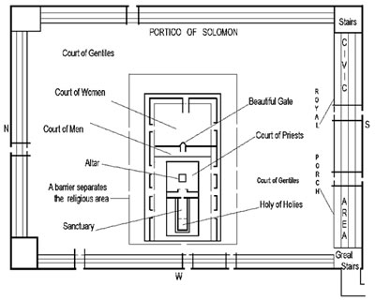

All quotations taken from the New American Standard unless otherwise noted. NASB. Nashville, TN: Thomas Nelson Publishers 1995. A free PDF of this note sheet is available: www.cssbchurch.org/sermons-2. © 2023.