QUESTIONS FOR ADDITIONAL STUDY

1. Tell your story. Describe a time in your life when something you

valued was lost or destroyed. How did you deal with that loss?

2. Why do you think people often ignore warnings?

3. Read the following passages and note the Bible says about the

importance of heeding warnings:

a) Proverbs 16:18

b) II Kings 17:13-15

c) Psalm 19:9-11

d) Ezekiel 3:17-18

e) Matthew 24:36-42

f) Luke 12:4-5

g) Hebrews 12:25

4. What was Jesus talking about when He referred to “the time of the

Gentiles?”

5. What practical application are you going to make from this week’s

message? (*Share your decision with another person*.)

* I am going to make it a point each day to pray for the peace of Jerusalem in obedience to Psalm 122:6-9.
* I am going to invite someone to attend church with me.
* I am going to memorize Proverbs 3:5-6.

Cornerstone Church January 5, 2025

Luke 21:20-24 Study Series #091

***The Destruction of Jerusalem***

**I. Introduction**

A. The History of Jerusalem

(See Genesis 22:2; Genesis 22:14; Psalm 122:6-9;

Zechariah 9:9-10)

B. The Geography of Jerusalem

(See Psalm 48:2; Psalm 121:1-2; Deuteronomy 12:5;

II Chronicles 6:6)

C. The Importance of Jerusalem

(See Luke 21:7; Matthew 24:16-21; Mark 13:14-17;

Daniel 9:24-27; Revelation 13:1-18)

**II. The Destruction of Jerusalem**

A. The Sign

(See Luke 21:20; Matthew 24:15; Mark 13:14)

B. The Instruction

(See Luke 21:21-22; Matthew 24:16-18; Mark 13:14-16;

Proverbs 3:5-6)

C. The Warning

(See Luke 21:23; Matthew 24:19-21; Mark 13:17-19)

D. The Future

(See Luke 21:24; Daniel 2:34-36; Daniel 2:44-45;

Revelation 19:11; I Corinthians 15:52)

**III. Conclusion**

**IV. Communion**

Communion at Cornerstone Church is open for all who profess Jesus Christ as their Lord and Savior. You do not have to be a member of Cornerstone or a member of a Southern Baptist Church to observe Communion with us. If you are a believer in Jesus Christ, you are welcome to take Communion. If you are not a believer in Jesus Christ, Scripture commands that you refrain taking Communion. (I Corinthians 11:26-31)

If you would like to know more about what it means to be a Christian, or if you would like to talk with someone or have someone pray for you, please see the pastor after the service and he or one of our church leaders will be glad to speak with you.

**Passage of Study**

**Luke 21:20-24**

**20**“But when you see Jerusalem surrounded by armies, then recognize that her desolation is near. **21**Then those who are in Judea must flee to the mountains, and those who are in the midst of the city must leave, and those who are in the country must not enter the city; **22**because these are days of vengeance, so that all things which are written will be fulfilled. **23**Woe to those who are pregnant and to those who are nursing babies in those days; for there will be great distress upon the land and wrath to this people; **24**and they will fall by the edge of the sword and will be led captive into all the nations; and Jerusalem will be trampled underfoot by the Gentiles until the times of the Gentiles are fulfilled.

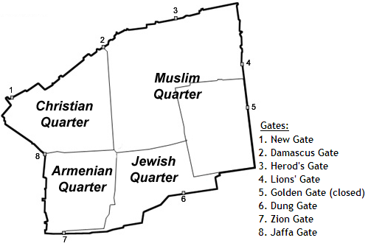

Figure 1

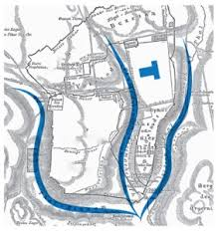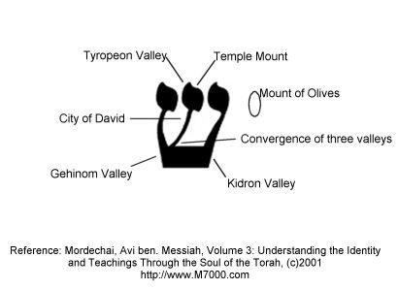

Figure 2 Figure 3

All quotations taken from the New American Standard unless otherwise noted. NASB. Nashville, TN: Thomas Nelson Publishers 1995. A free PDF of this note sheet is available: www.cssbchurch.org/sermons-2. © 2025.